Form SUAS 2
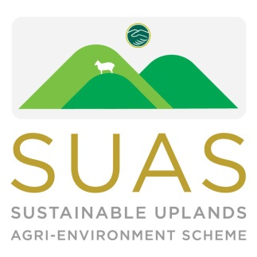
EUROPEAN INNOVATION PARTNERSHIPS

Sustainable Uplands Agri-environment Scheme (SUAS)

Expression of Interest Form
for
Non-Commonage Farms

Return to;
SUAS Project
C/O Wicklow Uplands Council Closing date: 2nd July, 2021
Main Street
Roundwood
Co Wicklow

Name:
Address:
Telephone:
6. Email address:
Townland of uplands:
Upland Area:
Please note: If you need assistance with completing this form please contact Brian at
(01) 2818406

Your Upland Area Details

Briefly describe your upland area under following headings;
Approximate stock numbers grazing on the uplands:
________________________________________________________________________________________________________________________________________________________________________________________________________________________________________________________________________________________________________________________________________________________________________
Area claimed for;
BPS: ________________________
GLAS: ________________________

Brief summary of the current condition of your upland area.

________________________________________________________________________________________________________________________________________________________________________________________________________________________________________________________________________________________________________________________________________

Are there archaeological sites present, public walking routes, is it designated as a SAC/SPA, any other relevant issues? Please give details where appropriate
_____________________________________________________________________________________________________________________________________________________________________________________________________________________________________________________

Why do you want to join the SUAS Pilot?
1. _______________________________________________________________________________
2 _______________________________________________________________________________
3 ______________________________________________________________________________

Details of proposed projects to be supported by SUAS

NOTE- All data contained in this expression of interest form will be used for the sole purpose of selecting commonages for the project and will not be shared with any other organisation.

